**Introducing Our Amazing Tutoring Services**

Whether you’re a child, parent or adult sometimes you can feel a bit lost tackling a subject, can’t you? If you’re struggling in lessons or feel like you could benefit from extra support and guidance, then we are the people to call.

Our team has a wealth of experience and we offer a wide range of support packages and tutoring services so whatever your needs we want to hear from you! We offer a personalised and friendly approach in all our services and will endeavour to deliver an enlightening and educational tutoring experience.

Because we work with a small amount and subject specialist tutors; we try not to promise we can help **everyone**. We believe that the one size fits all system doesn’t work and therefore one tutor may not be able to help every student to that walks through the door. However, we may these assessments prior to the first lesson, work closely with guardians reporting on progress and are honest when we can’t help/need to signpost students to a detailed service.

**Who Can We Help?**

We can help almost anyone! We know that everyone is different and how they approach a subject will have a big impact on their learning experience. That’s why we tailor our tutoring to the learner, so they’ll be sure to get the most out of the experience.

We also proudly offer help and support for home schooling students, we are based in Maidstone, Kent, England **and can also offer online tutoring services as well.** So, don’t worry you don’t need to live close by to take advantage of our amazing services.

We are happy to provide our services for children, teenagers and adults and our tutors are also equipped to help students with special needs and learning difficulties like dyslexia, dyscalculia, ADHS, Anxiety and depression. Private tutoring services are a great way for children and indeed adults who suffer from learning difficulties to attend to their learning needs, tailor lessons to suit and build confidence.

Whether it’s help with homework, some extra tuition to help you overcome a challenging subject or simply some extra support for an upcoming exam; our team are ready to help.

**What Subject Do We Help With?**

We offer a wide range of tutoring services and cover 8 subjects from primary levels to adult learners. We also cover a range of different awarding bodies as well. The subjects we currently offer are as follows.

• Primary English

• Primary Mathematics

• GCSE Mathematics

• GCSE English

• A-Level Mathematics

• Adult Learners Science

• Adult Learners English

• Adult Learners Mathematics

We follow the guidelines set out by the awarding bodies and examination boards closely. So, no matter what level you need help with you can be sure our tutoring packages will cover everything you need to achieve high marks on your exam and coursework. {Can we list the awarding bodies we work with here and link their websites?]

Whether you’re a parent looking for some extra-support for your child or and adult yourself who would like to better themselves, remember it’s never too late, get it touch today to start your journey towards a more enjoyable and enlightening educational journey.

Keen to add these quotes as it portrays the ethos we work towards;

 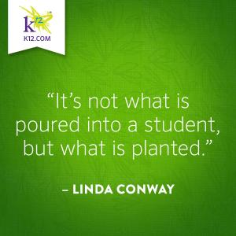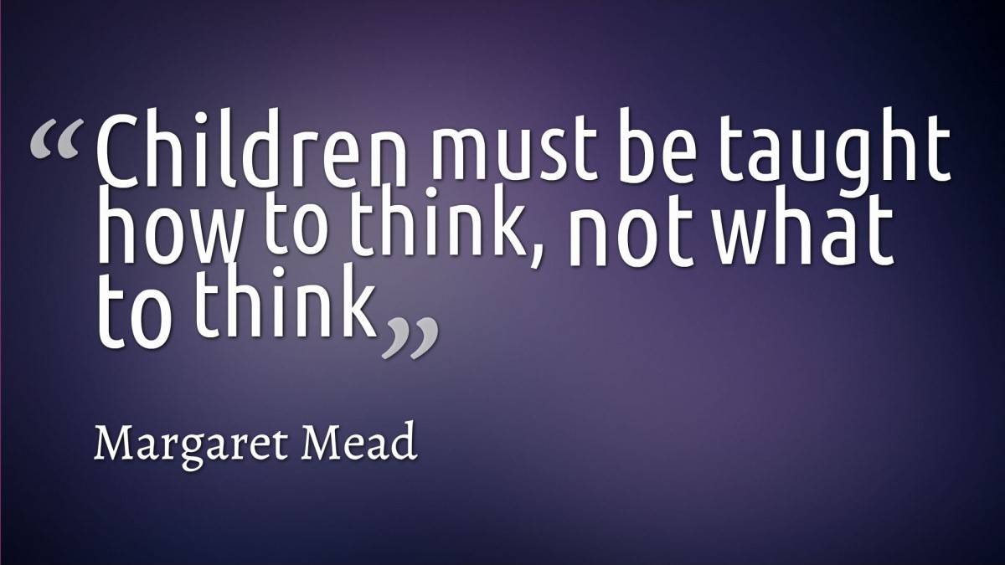 We don’t just give answers to questions. We take the time to help the student understand the topic, so that if a similar question came up, they would have the skills to tackle that question. We’re almost supporting a positive resilient attitude in students by creating a safe space in lessons where they can ask questions but also work towards the answer; giving them a sense of achievement, appreciation/ reflection of the progress they have made and the skills required to attempt exam questions without the tutor present at a later date. The new GCSEs target a student’s way of thinking rather than the ability to put an answer on paper. 